MATHEMATICS LECTURES BY
MANISH KALIA
(B.Tech Delhi College of Engineering)

sets

Section 1
- Definition: A set is a well-defined collection of objects.
There are two methods of representing a set
- Roaster or tabular form
e.g. natural numbers less than 5 = {1, 2, 3, 4}
(ii) Set builder form
e.g. : Vowels in English alphabet
= {x : x is a vowel in the English alphabet }
Section 2
- Types of sets

- Empty set or Null set or void set: A set which does not contain any element is called null set.
(ii) Finite set: A set which consists of a definite number of elements is called Finite set.
(iii) Infinite set: A set which consists of a indefinite number of elements is called infinite set.
(iv) Singleton set: A set having exactly one element is called singleton set.

- Subset :– A set A is said to be a subset of set B if a ∈A ⇒ a ∈B, ∀ a ∈Α
Note: If A ⊂ B and A ≠ B , then A is called a proper subset of B and B is called superset of A.

- Equal sets :– Two sets A and B are equal if they have exactly the same elements i.e A = B if A ⊂ Β and B ⊂ A

- Power set : The collection of all subsets of a set A is called power set of A, denoted by P(A) i.e. P(A) = { B : B ⊂ A }

- If A is a set with n(A) = m then n [P(A)] = 2^{m}.
- Equivalent sets : Two finite sets A and B are equivalent, if their cardinal numbers are same i.e., n(A) = n(B).

- Types of Intervals
Open Interval (a, b) = { x ∈ R : a < x < b }
Closed Interval [a, b] = { x ∈ R : a ≤ x ≤ b }
Semi open or Semi closed Interval,

(a,b] = { x ∈ R : a < x ≤ b}
[a,b) = { x ∈ R : a ≤ x < b}
Section 3
- Universal set
This is a basic set; in a particular context whose elements and subsets are relevant to that particular context. For example, for the set of vowels in
English alphabet, the universal set can be the set of all alphabets in English. Universal set is denoted by U
- Venn diagrams
Venn Diagrams are the diagrams which represent the relationship between sets. For example, the set of natural numbers is a subset of set of whole numbers which is a subset of integers. We can represent this relationship through Venn diagram in the following way.
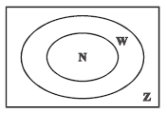
- Operations on sets
- Union of two sets A and B is,
A ∪ B = { x : x ∈ A or x ∈ B }
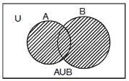
Properties of the operation of union.
(i) A ∪ B = B ∪ A (ii) (A ∪ B) ∪ C = A ∪ (B ∪ C)
(iii) A ∪ φ = A (iv) A ∪ A = A (v) U ∪ A = U

- Intersection of two sets A and B is,
A ∩ B = { x : x ∈ A and x ∈ B}
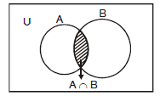
Properties of the operation of intersection
(i) A ∩ B = B ∩ A (ii) (A ∩ B) ∩ C = A ∩ (B ∩ C)
(iii) φ ∩ A = φ ; U ∩ A = A (iv) A ∩ A = A
(v) A ∩ (B ∪ C) = (A ∩ B) ∪ (A ∩ C)
(vi) A ∪ (B ∩ C) = (A ∪ B) ∩ (A ∪ C)
- Disjoint sets : Two sets A and B are said to be disjoint if A ∩ B = φ
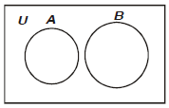
- Difference of sets A and B is,
A – B = { x : x ∈ A and x ∉ B}
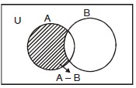
- Difference of sets B and A is,
B – A = { x : x ∈ B and x ∉ A }
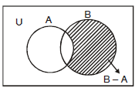
- Complement of a set A, denoted by A' or A^{c} is
A' = A^{c} = U – A = { x : x ∈ U and x ∉ A}
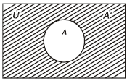
Properties of complement sets :
1. Complement laws
(i) A ∪ A' = U (ii) A ∩ A' = φ (iii) (A')' = A

2. De Morgan's Laws
(i) (A ∪ B)' = A' ∩ B' (ii) (A ∩ B)' = A' ∪ B'
3. φ' =  and  ' = φ
Section 4
Laws of Algebra of sets.
(i) A ∪ φ = A
(ii) A ∩ φ = φ
 A – B = A ∩ B'

 Commutative Laws :–
(i) A ∪ B = B ∪ A (ii) A ∩ B = B ∩ A

 Associative Laws :–
(i) (A ∪ B)∪ C = A ∪ (B ∪ C) (ii) (A ∩ B) ∩ C = A ∩ (B ∩ C)

 Distributive Laws :–
(i) A ∩ (B ∪ C) = (A ∩ B) ∪ (A ∩ C)
(ii) A ∪ (B ∩ C) = (A ∪ B) ∩ (A ∪ C)

 If A ⊂ B, then A ∩ B = A and A ∪ B = B

 When A and B are disjoint n(A ∪ B) = n(A) + n(B)

 When A and B are not disjoint
n(A ∪ B) = n(A) + n(B) – n(A ∩ B)

 n(A ∪ B ∪ C) = n(A) + n(B) + n(C) – n(A ∩ B) – n(B ∩ C) – n(A ∩ C) + n(A ∩ B ∩ C)
Some important symbols
N : the set of all natural numbers
Z : the set of all integers
Q : the set of all rational numbers
R : the set of real numbers
Z⁺ : the set of positive integers
Q⁺ : the set of positive rational numbers, and
R⁺ : the set of positive real numbers.

Worksheet CSBE
Q1 Write the set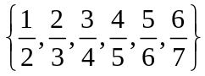,in the set builder form
Ans: 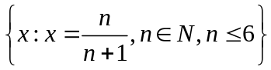
Q2 Write the following sets in the roaster form.
(i) A = {x : x is a positive integer less than 10 and 2^{x} – 1 is an odd number}
(ii) C = {x : x² + 7x – 8 = 0, x ∈ R}
Ans: i) {1, 2, 3, 4, 5, 6, 7, 8, 9}.
ii) {– 8, 1}
Q3 From 50 students taking examinations in Mathematics, Physics and Chemistry, each of the student has passed in at least one of the subject, 37 passed Mathematics, 24 Physics and 43 Chemistry. At most 19 passed Mathematics and Physics, at most 29 Mathematics and Chemistry and at most 20 Physics and Chemistry. What is the largest possible number that could have passed all three examination?
Ans: 14

Q4 Each set Xr contains 5 elements and each set Yr contains 2 elements and 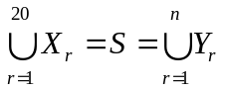. If each element of S belong to exactly 10 of the Xr’s and to exactly 4 of the Yr’s, then n is equal to.
Ans: 20

Q5 In a town of 10,000 families, it was found that 40% families buy newspaper A, 20% families buy newspaper B and 10% families buy newspaper C. 5% families
buy A and B, 3% buy B and C and 4% buy A and C. If 2% families buy all the three
papers. Find the no. of families which buy
- A only (ii) B only (iii) none of A, B, and C.
Ans: i)3300
ii)1400
iii)4000

Q6 Two finite sets have m and n elements. The total no. of subsets of the first set is
56 more than the total no. of subsets of second set. Find the value of m and n.
Ans: 6
Q7 A college awarded 38 medals in football, 15 in basketball and 20 in cricket. If these medals went to a total of 58 men and only three men got medals in all the three sports, how many received medals in exactly two of the three sports ?
Ans: 9
Q8 Let A and B be sets. If A ∩ X = B ∩ X = φ and A ∪ X = B ∪ X for some set X, show that A = B.
Q9 List all the subsets of the set {-1,0,1}
Ans:
Q10 Let U = {1, 2, 3, 4, 5, 6} A = {2, 3} and B = {3, 4, 5} Find A′∩B′, A∪B and hence show that (A∪B)′ = A′∩B′ .
Ans: (A∪B)′ = A′∩B′ ={1, 6}

